Customer Revenue Opportunity Intelligence Platform
Subtitle: - An AI-Powered Decision Support System for Customer Prioritization, Revenue Growth, Product Recommendation, and Business Intelligence

APPROVAL PITCH QUESTION
User, current problem and why it matters.?
=> The primary users are Sales Managers, Marketing Teams, Revenue Managers, Product Managers, and Small Business Owners.

Many businesses collect large amounts of customer and sales data through ERP systems, e-commerce platforms, and CRM (customer relationship management) software. However, most businesses only use this data to generate reports and dashboards. While these reports show what has happened, they do not help managers decide what action should be taken next.
For example, a sales manager may know the total revenue for the month but may not know which customers should be contacted first, which products should be promoted, or which regions require immediate attention. As a result, businesses often miss revenue opportunities, lose valuable customers, and make decisions based on intuition instead of data.
This problem is important because increasing competition requires businesses to make faster and smarter decisions. A delay in identifying valuable customers or market opportunities can directly affect revenue, customer retention, and business growth. Therefore, organizations need an intelligent decision-support platform that not only analyses data but also predicts future opportunities and recommends the next best business actions.

Instead of providing only dashboards and reports, the platform helps these users understand what action should be taken next, making it a complete decision-support system.

Most organizations are data-rich but insight-poor. They can see what has happened, but they often lack the intelligence to decide what should happen next.

Decision to improve and how success will be measured

✅ Decision to Improve
- Customer prioritization
- Revenue optimization
- Product recommendation
- Sales prioritization
- Business decision-making

✅ Success Measurement
Business Metrics
- Customer Retention Rate
- Repeat Purchase Rate
- Revenue Growth
- Average Order Value (AOV)
- Product Recommendation Effectiveness

Technical Metrics
- Accuracy
- Precision
- Recall

Dataset proof: source, sample rows, fields, size and grain.
Item | Details
Dataset Name | Olist Brazilian E-commerce Public Dataset
Source | Kaggle
Type | Real-world E-commerce Dataset
Time Period | 2016–2018
Tables | 9 interconnected tables
Orders | ~100,000
Customers | ~99,000
Products | ~33,000
Order Items | ~300,000+
Primary Grain | One Customer Order (Order ID)

Grain means what each row of the dataset represents. In our project, the primary grain is one customer order represented by a unique Order ID.

Expected product: ML output, Power BI pages, AI feature, automation and deployment.
  - It will use machine learning to generate customer segments, purchase predictions, revenue forecasts, product recommendations, and Opportunity Scores. The platform will include interactive Power BI dashboards for customer, product, revenue, and geographic analysis. It will provide AI-generated business recommendations instead of only numerical reports, automate alerts and weekly reports using n8n, and be deployed as a Streamlit web application connected to a PostgreSQL database.

MVP, optional features and biggest risks.
  - The Minimum Viable Product (MVP) of our project is a working Customer Revenue Opportunity Intelligence Platform that allows users to upload sales data, processes it through an ETL pipeline, stores it in a PostgreSQL database, generates customer segmentation, purchase prediction, revenue forecasting, and displays interactive Power BI dashboards. It will also provide AI-generated business recommendations and basic workflow automation.

  - Optional Features
These are not mandatory, but if completed they make the project stronger:
- AI Chat Assistant for business queries.
- Personalized marketing campaign suggestions.
- Role-based login (Admin, Sales Manager, Marketing Manager).
- Downloadable PDF executive reports.

  - Risk and Future challenges:
- Dataset Structure Mismatch: Different organizations may have different column names, formats, or data structures, requiring column mapping and standardization.
- Missing or Incomplete Data: Uploaded datasets may have missing values or required fields, affecting analytics and machine learning predictions.
- Poor Data Quality: Duplicate records, incorrect values, inconsistent formats, or invalid data can reduce the reliability of insights.
- Machine Learning Generalization: Models trained on one dataset may not perform equally well on datasets from different businesses or industries.
- Integration Complexity: Integrating PostgreSQL, Python ETL, Machine Learning, Power BI, Streamlit, AI, and n8n into a single platform may introduce compatibility issues.
- Large Dataset Performance: Processing very large datasets may increase execution time and dashboard loading time.
- Automation Failures: Scheduled workflows or notifications may fail due to configuration or service issues.
- AI Service Availability: If an external AI service is unavailable, AI-generated summaries and recommendations may not be generated.
- Deployment Challenges: Hosting, database connectivity, and application configuration issues may occur during deployment.

- What real problem are you solving?
=> Businesses like E commerce platform collect large amounts of customer and sales data, but they struggle to convert that data into actionable decisions that increase revenue.
Many organizations know:
- Who bought their products.
- What products were purchased.
- How much revenue was generated.
But they do not know:
- Which customers deserve immediate attention.
- Which customers are likely to generate the highest future revenue.
- Which customers are at risk of leaving.
- Which products should be recommended to increase sales.
- Which marketing strategy should be used for different customer groups.
- Which business metrics require immediate action.
As a result:
- High-value customers may be ignored.
- Marketing budgets are wasted on the wrong audience.
- Cross-selling and upselling opportunities are missed.
- Customer retention decreases.
- Revenue growth slows despite having large amounts of data.

Our Solution: The Customer Revenue Opportunity Intelligence Platform is an AI-powered decision support system that converts raw customer and sales data into actionable business intelligence.
The platform will:
- Analyse customer behaviour.
- Segment customers based on value.
- Predict future revenue opportunities.
- Recommend products for cross-selling and upselling.
- Identify customers at risk of churn.
- Prioritize customers for sales and marketing teams.
- Provide interactive dashboards for executives.
Instead of simply showing reports, the system tells businesses:
- Who should be contacted first?
- Which customers are most valuable?
- Who is likely to leave?
- Which products should be recommended?
- Where is future revenue likely to come from?
- What actions should management take?

- What decision will your product improve?
  - Which customers should the business prioritize and what action should be taken to maximize revenue?
  - The product improves strategic business decisions by helping organizations prioritize customers, identify revenue opportunities, recommend products, retain valuable customers, and support management with data-driven business intelligence.
  - It improves the decision of how businesses should allocate their sales, marketing, and customer engagement efforts to the right customers at the right time in order to maximize revenue and long-term customer value.

- What action happens after the analysis or prediction?
  - After analysis and prediction, the platform generates actionable recommendations that support business decisions. Sales teams prioritize high-value customers, marketing teams launch targeted campaigns, customer success teams intervene to retain at-risk customers, and management uses dashboards to allocate resources and plan growth strategies. In this way, analytics is transformed into business actions that drive revenue growth, improve customer retention, and increase overall business performance.
  - The platform will answer questions such as:
- Who should we contact first?
- Which customers need retention efforts?
- Which products should we recommend?
- Where should we invest our marketing budget?
- Which customers have the highest future value?
The sales, marketing, and management teams then use these insights to act.
Stakeholders

These are the people who will actively use the platform.
1. Sales Team
Role:
- Prioritize customers to contact.
- Focus on high-revenue opportunities.
- Use customer insights to improve conversions.
Uses:
- Customer priority scores
- Revenue opportunity rankings
- Customer profiles

2. Marketing Team
Role:
- Design targeted campaigns.
- Improve campaign ROI (Return On Investment).
- Increase cross-selling and upselling.
Uses:
- Customer segments
- Product recommendations
- Customer behaviour analysis
3. Customer Success / CRM Team
Role:
- Retain customers.
- Reduce churn.
- Improve customer satisfaction.
Uses:
- Churn risk predictions
- Customer engagement insights
- Retention recommendations

4. Business Managers / Executives
Role:
- Make strategic business decisions.
- Monitor company performance.
- Allocate budgets and resources.
Uses:
- Executive dashboards
- KPIs
- Revenue trends
- Business intelligence reports

These stakeholders may not use the platform daily but are affected by it.
5. Business Owner / CEO
Interested in:
- Revenue growth
- Customer lifetime value
- Profitability
- Overall business performance

COMPLETE PROJECT WORKFLOW
- Business Problem
- Business Requirement Analysis
- Dataset Research & Selection
- Data Understanding
- Data Validation (Excel)
- SQL Database Design
- Python ETL Pipeline (ETL : extract, transform and load)
- Data Cleaning
- Exploratory Data Analysis
- Business KPI Design
- Feature Engineering
- Machine Learning
- Revenue Opportunity Engine
- AI Decision Assistant
- Power BI Dashboard
- Automation (n8n)
- Deployment
- Testing
- Documentation

HOW PLATFORM LOOKS LIKE
A Streamlit-based web application that behaves like an enterprise analytics platform.
  - Home
Project overview and KPIs.
  - Executive Dashboard
Revenue, profit, opportunity metrics.
  - Customer 360
Search any customer and view their profile.
  - Product Recommendation
Next Best Product engine.
  - Opportunity Center
Top customers to contact.
  - Revenue Forecast
Future revenue predictions.
  - AI Assistant
Ask business questions in natural language.
  - Reports
Download insights and summaries.

If stakeholders search for any customer
Customer: Rahul Sharma
Opportunity Score: 92
Revenue Potential: ₹26,500
Next Product: Laptop Stand
Profit Margin: High
Priority: Contact Today
AI Summary:
Recommended Action:
Offer a product bundle without discount.

The Streamlit app becomes your single platform, where users can:
- View Power BI dashboards
- Search customers
- Run predictions
- View AI-generated explanations

TECHNOLOGY STACK USING IN PROJECT
Layer | Technology | Why We Are Using It
Data Source | Kaggle/UCI Retail Dataset | Raw business data
Data Validation | Excel | Initial validation, business verification, data dictionary
Database | PostgreSQL / SUPABASE | Central relational database for clean data
Data Engineering | Python (Pandas, NumPy) | ETL, cleaning, transformation, feature engineering
SQL | PostgreSQL | Business queries, views, KPIs
Machine Learning | Scikit-learn + XGBoost + MLxtend (Association Rules) | Segmentation, prediction, recommendation, Opportunity Score
Business Intelligence | Power BI | Executive dashboards and analytics
Web Application | Streamlit | User-facing analytics platform
AI Features | LLM API (Gemini/ Ollama) | Customer summaries, recommendations, business insights
Automation | n8n | Scheduled reports, alerts, workflow automation
Version Control | Git + GitHub | Code management and collaboration
- Python (pandas and numpy) prepares and analyzes the data.
- SQL/PostgreSQL stores and manages it.
- Machine Learning generates predictions.
- Power BI visualizes insights.
- Streamlit provides the user interface.
- n8n automates notifications and workflows.

Scikit-learn for: - Classification, Regression, Clustering
XGBoost for: - High accuracy prediction, Revenue prediction, Purchase prediction
MLxtend for: - Next best product recommendation.

Streamlit: - It is a Python framework that lets you build interactive web applications (websites) using only Python. (instead of learning react, html, CSS and JavaScript with the help of streamlit we can build analytics applications in few days)
- In streamlit we can easily run ML models
- There are two options for Power BI in streamlit: -
Option 1
Open Power BI separately.
Option 2
Embed Power BI inside Streamlit.

WHAT IF THE OTHER DATASET DOESNOT CONTAIN SAME COLUMNS NAME OR SAME COLUMN

Solution 3: User-Assisted Mapping (Best Balance)
This is the option I recommend for your project.
Step 1
User uploads a CSV.
Step 2
The platform detects the uploaded columns:
Cust_ID
Product
Revenue
OrderDate
Step 3
The platform asks the user:
Your Column | Standard Column
Cust_ID | Customer_ID
Product | Product_Name
Revenue | Sales
OrderDate | Order_Date
The user confirms the mapping.

Step 4
The system remembers the mapping and processes the file.
This is how many enterprise ETL tools work.

How We'll Implement It
We'll define one standard schema for our platform.
Example:
Customer_ID
Order_ID
Order_Date
Product_ID
Product_Name
Category
Quantity
Sales
Profit
Discount
Region
Every uploaded dataset will be converted into this format.

DATASET

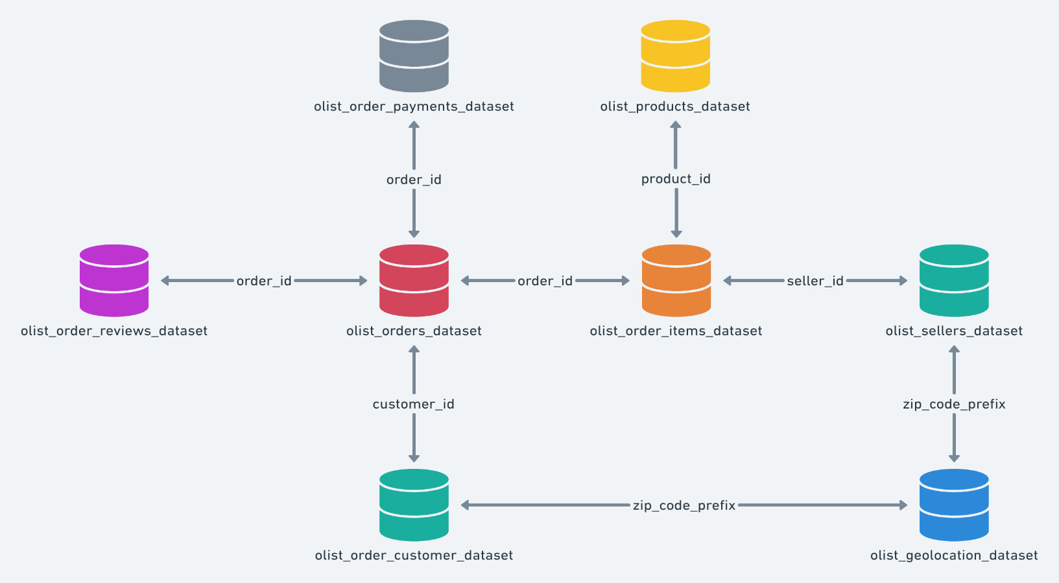

1. olist_customers_dataset ⭐⭐⭐⭐⭐
This is your Customer Master Table.
Contains information like:
- Customer ID
- Customer unique ID
- ZIP code
- City
- State
We'll use it for:
- Customer segmentation
- Regional analysis
- Customer 360
- Power BI maps

2. olist_orders_dataset ⭐⭐⭐⭐⭐
This is the heart of the entire database.
Contains:
- Order ID
- Customer ID
- Order Status
- Purchase Timestamp
- Delivery Date
Almost every other table connects through this one.

We'll use it for:
- Revenue timeline
- Customer activity
- Churn prediction
- Purchase frequency
- Revenue Opportunity Score

3. olist_order_items_dataset ⭐⭐⭐⭐⭐
This tells us:
Which products were bought in each order.
Contains:
- Order ID
- Product ID
- Seller ID
- Price
- Freight Value
This is one of the most important tables.
We'll use it for:
- Product recommendation
- Revenue calculation
- Basket analysis
- Product popularity
- Average order value

4. olist_products_dataset ⭐⭐⭐⭐⭐
Contains:
- Product ID
- Category
- Product dimensions
- Weight
We'll use it for:
- Category analysis
- Product recommendation
- Product performance dashboards

5. olist_order_payments_dataset ⭐⭐⭐⭐
Contains:
- Order ID
- Payment Type
- Payment Installments
- Payment Value
Useful for:
- Payment behavior
- Installment analysis
- Revenue validation

6. olist_order_reviews_dataset ⭐⭐⭐⭐
Contains:
- Review Score
- Review Comments
- Review Date
This is actually very interesting.
We can build:
Customer Satisfaction Dashboard
or
Review Sentiment Analysis (optional)

7. olist_sellers_dataset ⭐⭐⭐
Contains:
- Seller ID
- Seller Location
Useful if we later want:
Seller Performance Dashboard
Not essential.

8. olist_geolocation_dataset ⭐⭐
Contains:
- Latitude
- Longitude
Useful for:
- Maps
- Delivery analysis
Probably optional for our MVP.

Which tables do we actually need?
We don't need all 8 tables for the first version.
I would use these.
Table | Use
Customers | ✅
Orders | ✅
Order Items | ✅
Products | ✅
Payments | ✅
Reviews | Optional
Sellers | Optional
Geolocation | Optional

WHAT ONE ROW REPRESENTS?
  - One row represents in customer table , one unique customer, in orders table one customer order, in orders items table one product within an order, in products table one unique product, in payments table one payment transaction for an order.

WHAT IS THE MAIN BUSINESS METRICS?
  - Business metrics is the numbers the help managers to make decisions

  - Revenue
    - Total Revenue
    - Monthly Revenue
    - Revenue Growth
  - Customers
    - Total Customers
    - Active Customers
    - Repeat Customers
    - Customer Lifetime Value
    - Average Order Value

  - Orders
    - Total Orders
    - Purchase Frequency
  - Products
    - Best Selling Products
    - Revenue by Category
  - Intelligence (Unique to Our Platform)
    - Opportunity Score
    - Revenue Potential
    - Next Best Product
    - Customer Priority Level

PROPOSED ML TASK?

ML Task | Algorithm | Learning Type
Customer Segmentation | K-Means | Unsupervised
Purchase Prediction | Random Forest / XGBoost | Classification
Revenue Opportunity Score | Custom scoring model using ML outputs + business rules | Hybrid
Product Recommendation | Apriori / FP-Growth (MLxtend) | Association Learning
Revenue Forecast | Prophet / XGBoost Regression / Linear Regression | Time Series / Regression
Raw Data
│
▼
Data Cleaning
│
▼
Feature Engineering
│
▼
Processed Dataset
│
┌────┼────────┬──────────┬─────────┐
▼ ▼ ▼ ▼
Seg. Purchase Forecast Recommendation
│
└──────────┬──────────────┘
▼
Revenue Opportunity Score
▼
Streamlit + Power BI

COMPLETE FILES STRUCTURE
Customer Revenue Opportunity Intelligence Platform

├── data/
│ ├── raw/
│ ├── processed/
│
├── notebooks/
│ ├── 01_Data_Cleaning.ipynb
│ ├── 02_EDA.ipynb
│ ├── 03_Feature_Engineering.ipynb
│ ├── 04_Machine_Learning.ipynb
│
├── models/
│ ├── segmentation.pkl
│ ├── purchase_prediction.pkl
│ ├── revenue_forecast.pkl
│ ├── feature_columns.pkl ← stores the expected feature names/order
│ └── scaler.pkl ← if feature scaling is used
│
├── database/
│ ├── schema.sql
│ ├── queries.sql
│
├── powerbi/
│ └── Dashboard.pbix
│
├── app/
│ ├── streamlit_app.py
│ ├── pages/
│ └── utils/
│
├── automation/
│ └── n8n_workflow.json
│
├── requirements.txt
├── README.md
└── .gitignore

WHAT ARE TH]E DIFFERENT POWER BI PAGES

Page 7 – ML Insights
This page is what makes your project different.
Instead of showing only charts,
we'll show ML results.
Example:

Customer Segment
High Value
Purchase Probability
92%
Opportunity Score
95
Revenue Forecast
$15,200
Recommendation

Laptop Bag

🎯 Page 8 – Opportunity Center
This will be unique.
Instead of only analysis,
it tells managers what to do.
Example:
Customer | Score | Action
Rahul | 96 | Call Today
Priya | 90 | Offer Premium Product
Amit | 82 | Send Email Campaign
This transforms the dashboard into a decision-support system

AI FEATURES IN MY PROJECT?
  - Instead of just giving the numerical data like what are the status it will give proper improvements like what to do to increase the performance, give business insights, improvements what we need to do.
  - The platform not only analyses customer and revenue data but also generates actionable business recommendations, enabling managers to make faster and more informed decisions.
- Gemini API (Free Tier)
- Ollama + Llama 3 (runs locally, no API cost)
AI Feature | Business Value
AI Customer Summary | Customer understanding
AI Executive Summary | Faster management decisions
AI Segment Explanation | Explain clustering results
AI Opportunity Explanation | Explain scores
AI Next Best Action | Recommend business actions
AI Product Recommendation Explanation | Explain recommendations
AI Campaign Message Generator | Marketing support
AI Weekly Report Summary | Automated reporting

AUTOMATION ACTIONS: for automation we will use n8n
n8n: n8n is a popular open-source workflow automation platform that lets you visually build, manage, and scale complex automations, including AI-powered workflows, across apps, APIs, and systems.
Automation | Why
High Opportunity Customer Alert | Directly supports sales decisions
Weekly Executive Report | Management reporting
Automated Dashboard Refresh | Keeps reports up to date
Inactive Customer Alert | Customer retention
AI Business Summary Report | Executive decision support
- Automated Data Processing
  - When a new sales dataset is uploaded, the system automatically validates, cleans, and stores the data in the database.
- Automatic Dashboard Refresh
  - After the data is updated, the Power BI dashboard is refreshed automatically so users always see the latest insights.

- Automatic Machine Learning Predictions
  - The platform automatically recalculates customer segments, purchase predictions, revenue forecasts, and Opportunity Scores whenever new data is processed.
- High-Priority Customer Alert
  - Customers with high Revenue Opportunity Scores are automatically identified and added to a priority action list for the sales team.
- AI-Generated Business Recommendations
  - Based on the latest analytics and ML predictions, the platform automatically generates recommendations such as which customers to contact, which products to promote, and which regions need attention.
- Weekly Executive Report
  - The system automatically generates a weekly business summary containing key performance metrics, trends, forecasts, and recommended actions for management.

DEPLOYEMENT PATH
End Users
(Sales Manager / Marketing Team / Business Owner)
│
▼
Streamlit Web Application
│
┌───────────────────┼───────────────────┐
▼ ▼ ▼
Machine Learning PostgreSQL DB Power BI Reports
Models (.pkl) (Data) (Embedded/Linked)
│ ▲
│ │
└────────── Python ETL Pipeline ──────────┐
│
Uploaded Sales Data
(CSV / Excel)
│
▼
n8n Automation

Step 1 – User Uploads Data
- Business uploads a CSV or Excel sales dataset through the Streamlit web application.

Step 2 – Python ETL Pipeline
The system automatically:
- Validates the uploaded file
- Cleans missing or incorrect values
- Standardizes column names
- Creates required features
- Loads the processed data into PostgreSQL

Step 3 – Database Update
The cleaned data is stored in the PostgreSQL database.
This becomes the single source of truth for:
- Power BI
- Machine Learning
- Streamlit

Step 4 – Machine Learning
The platform loads the trained models and generates:
- Customer Segments
- Purchase Predictions
- Revenue Forecast
- Product Recommendations
- Revenue Opportunity Scores

Step 5 – Power BI
Power BI reads data from PostgreSQL and displays:
- Executive Dashboard
- Customer Intelligence
- Product Intelligence
- Revenue Intelligence
- Geographic Intelligence
- Opportunity Dashboard

Step 6 – AI Decision Support
The platform generates:
- Customer summaries
- Business summaries
- Opportunity explanations
- Next Best Actions
- Product recommendation explanations

Step 7 – n8n Automation
Finally, automation:
- Refreshes dashboards
- Generates weekly reports
- Identifies high-priority customers
- Creates executive summaries
- Sends notifications (or prepares reports)

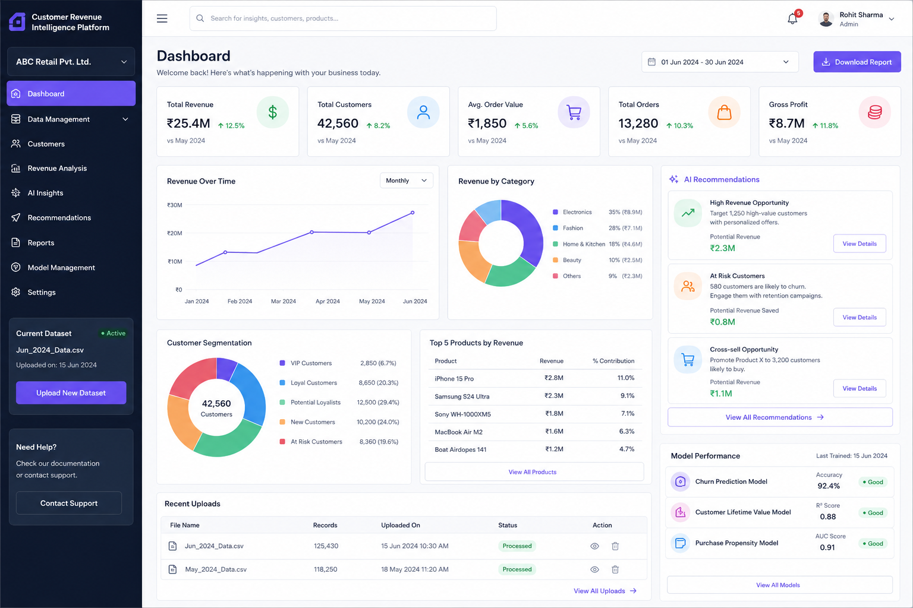
8 – WEEK MVP(MINIMUM VIABLE PRODUCT)

📅 Week 1 – Project Planning & Approval
Objective
Finalize the project idea and obtain faculty approval.
Deliverables
- ✅ Final project title
- ✅ Problem statement
- ✅ Project objectives
- ✅ Stakeholders
- ✅ Dataset selection (Olist E-commerce Dataset)
- ✅ Data grain definition
- ✅ System architecture diagram
- ✅ Technology stack
- ✅ 8-week project plan
- ✅ Risk analysis
MVP
Approved project proposal with complete project architecture and implementation plan.

📅 Week 2 – Data Foundation
Objective
Prepare a clean and reliable dataset.
Tasks
- Import all dataset tables
- Understand relationships
- Create PostgreSQL database
- Design SQL schema
- Build Python ETL pipeline
- Handle missing values
- Remove duplicates
- Standardize data
- Create data dictionary
- Perform Excel validation
- Data quality checks
Deliverables
- Clean dataset
- SQL database
- ETL pipeline
- Data dictionary
MVP
A fully cleaned and integrated database ready for analysis and machine learning.

📅 Week 3 – Exploratory Data Analysis & Power BI
Objective
Generate business insights and build the first dashboard.
Tasks
- Exploratory Data Analysis (EDA)
- Identify trends
- Calculate business metrics
- Design Power BI data model
- Build dashboard pages:
  - Executive Dashboard
  - Customer Intelligence
  - Product Intelligence
  - Revenue Intelligence
Deliverables
- EDA report
- Business metrics
- Initial Power BI dashboard
MVP
Interactive Power BI dashboard showing customer, product, and revenue insights.

📅 Week 4 – Machine Learning Baseline
Objective
Develop the first predictive models.
Tasks
- Feature engineering
- Train Customer Segmentation model
- Train Purchase Prediction model
- Train Revenue Forecast model
- Evaluate baseline performance
- Save trained models
Deliverables
- ML notebook
- Trained models (.pkl)
- Evaluation metrics
MVP
Working ML models capable of generating customer segments, purchase predictions, and revenue forecasts.

📅 Week 5 – Intelligence Module Development
Objective
Transform predictions into business intelligence.
Tasks
- Improve ML models
- Build Product Recommendation system
- Develop Revenue Opportunity Score
- Generate customer ranking
- Error analysis
- Model comparison
Deliverables
- Product recommendation module
- Opportunity Score algorithm
- Improved ML models
MVP
Platform identifies high-value opportunities and recommends the next best products.

📅 Week 6 – Platform Development & AI Integration
Objective
Build the user-facing application.
Tasks
- Develop Streamlit application
- Connect database
- Load ML models
- Integrate Power BI
- Implement AI features:
  - Customer summaries
  - Business summaries
  - Next Best Action
  - Recommendation explanations
Deliverables
- Working Streamlit application
- AI Decision Support module
MVP
Users can upload data, view dashboards, receive predictions, and get AI-generated business recommendations through a web application.

📅 Week 7 – Automation & Deployment
Objective
Automate workflows and prepare the project for deployment.
Tasks
- Configure n8n workflows
- Dashboard refresh automation
- Weekly executive report automation
- High Opportunity Customer alerts
- User testing
- Documentation
- GitHub repository
- Deploy Streamlit application
Deliverables
- Automated workflows
- Deployed application
- Project documentation
MVP
Complete analytics platform with automated reporting, alerts, and a deployed web application.

📅 Week 8 – Final Product & Presentation
Objective
Complete, test, and present the project.
Tasks
- Final testing
- Performance optimization
- Bug fixes
- Final Power BI dashboard
- Final documentation
- GitHub update
- Prepare presentation
- Demonstration
Deliverables
- Final deployed project
- Power BI dashboard
- Streamlit application
- GitHub repository
- Project report
- Presentation
MVP
A fully functional Customer Revenue Opportunity Intelligence Platform that combines data analytics, machine learning, AI-powered decision support, interactive dashboards, and workflow automation into a single business solution.

WORKING
Developed a complete ETL pipeline for the Customer Revenue Opportunity Intelligence Platform. The pipeline automatically extracts raw Olist datasets, performs data cleaning and validation, generates quality reports, and loads the processed data into PostgreSQL. The entire workflow is orchestrated through a single run_etl.py script, enabling end-to-end automation of data preparation and storage for downstream feature engineering and machine learning tasks.
A. config.py
This is the "brain" of the ETL pipeline.
It contains:
- Dataset names
- File locations
- Primary keys
- Validation rules
- Required columns
Example:
customers:
file = olist_customers_dataset.csv
primary_key = customer_id
Purpose
Instead of writing information repeatedly in every file, we store it once inside config.py.
When run_etl.py starts, it asks config.py:
Which datasets exist?
Where are they stored?
What are their primary keys?
That's why you see:
dict_keys([
'customers',
'orders',
'order_items',
'products',
'sellers',
'payments',
'reviews',
'geolocation',
'category_translation'
])
This is config.py returning all dataset names.

B. cleaning.py
This is the cleaning engine.
It contains reusable functions such as:
Standardize column names
Customer ID
becomes
customer_id

Convert blank values
""
becomes
NaN

Remove duplicate rows
drop_duplicates()

Remove missing primary keys
Example:
customer_id = NULL
row gets removed.

Clean text
" Mumbai "
becomes
"Mumbai"

Convert dates
01-08-2026
becomes
datetime

Convert numeric columns
"100"
becomes
100

Output
Creates cleaned files inside:
Dataset/
└── processed/
Example:
olist_customers_dataset_cleaned.csv
olist_orders_dataset_cleaned.csv

C. validation.py
After cleaning, validation.py checks data quality.
Checks:
Required Columns
Example:
customer_id
customer_city
must exist.

Not Null Check
customer_id
cannot be NULL.

Unique Check
customer_id
must be unique.

Foreign Key Check
Example:
orders.customer_id
must exist in
customers.customer_id

Numeric Range Check
Example:
payment_value > 0

Date Sequence Check
Example:
order_purchase_timestamp
<
order_delivered_customer_date

Output
Creates:
reports/
└── validation_report.csv

D. run_etl.py
This is the master controller.
You run only:
python run_etl.py
and it automatically:
Step 1: Read Configuration
config.py
- Reads dataset paths
- Reads validation rules
- Reads primary keys and settings
- Provides configuration to the rest of the pipeline
Step 2: Clean Data
cleaning.py
For each dataset:
- Load CSV from Dataset/raw
- Standardize column names
- Convert blank values to NaN
- Remove duplicates
- Remove missing primary keys
- Clean text fields
- Convert numeric/date columns
- Save cleaned CSVs into:
Dataset/processed/
Step 3: Generate Cleaning Report
Creates:
reports/cleaning_report.csv
containing:
Dataset
Rows Before
Rows After
Duplicates Removed
Missing PK Removed
Status
Step 4: Validate Data
validation.py
Checks:
- Required columns
- Null values
- Unique constraints
- Foreign keys
- Numeric ranges
- Allowed values
- Date sequence rules
Step 5: Generate Validation Report
Creates:
reports/validation_report.csv
Step 6: Load Data into PostgreSQL
load_to_postgres.py
Loads:
customers
orders
order_items
products
sellers
payments
reviews
geolocation
category_translation
and optionally:
cleaning_report
validation_report
into PostgreSQL tables.

Why pycache Folder Is Created

Python automatically creates it.
Example:
__pycache__/
contains
cleaning.cpython-313.pyc
config.cpython-313.pyc
validation.cpython-313.pyc

What are .pyc files?
Compiled Python files.
Python converts:
cleaning.py
into
cleaning.cpython-313.pyc
for faster execution.
THESE ARE AUTOMATIC GENERATED FILES

What is venv?
venv stands for Virtual Environment.
Think of it as a separate mini-Python installation created only for your project.
Why do we need venv?
Imagine:
Project A
Needs:
pandas 2.2
numpy 2.0
Project B
Needs:
pandas 1.5
numpy 1.23
If both projects use the same Python installation, package versions can conflict.
Using venv:
Project A -> Own packages
Project B -> Own packages
No conflicts.

